Triakis Tetrahedron

Definition
# Source: AI Source: Provided by: [Data Path: Persons Table -> ID Column: 1, Name_En Column: Motasem Essam] -> From: [ChatGPT] on [7/25/2026]
A Triakis Tetrahedron is a convex Catalan solid formed by attaching a triangular pyramid to each of the four faces of a regular tetrahedron.
It has 12 congruent isosceles triangular faces, 18 edges, and 8 vertices.
It is also known as a Tristetrahedron or Kistetrahedron. It is the dual polyhedron of the truncated tetrahedron, an Archimedean solid.

Simple Definition
# Source: AI Source: Provided by: [Data Path: Persons Table -> ID Column: 1, Name_En Column: Motasem Essam] -> From: [ChatGPT] on [7/25/2026]
A Triakis Tetrahedron looks like a tetrahedron with four triangular pyramids added to its four faces, creating a pointed, faceted solid.
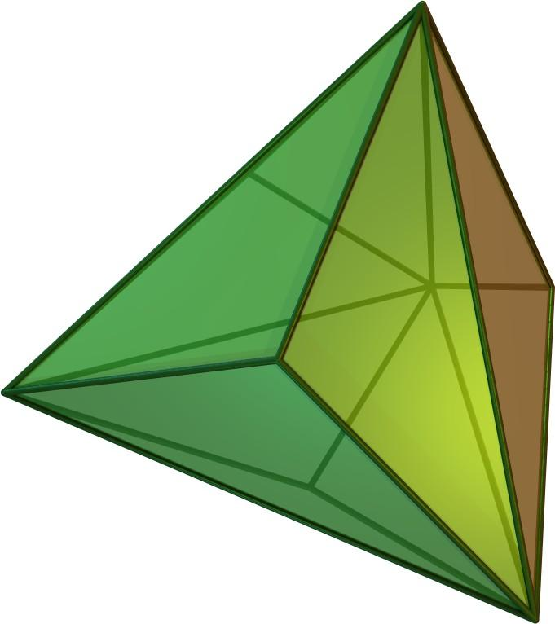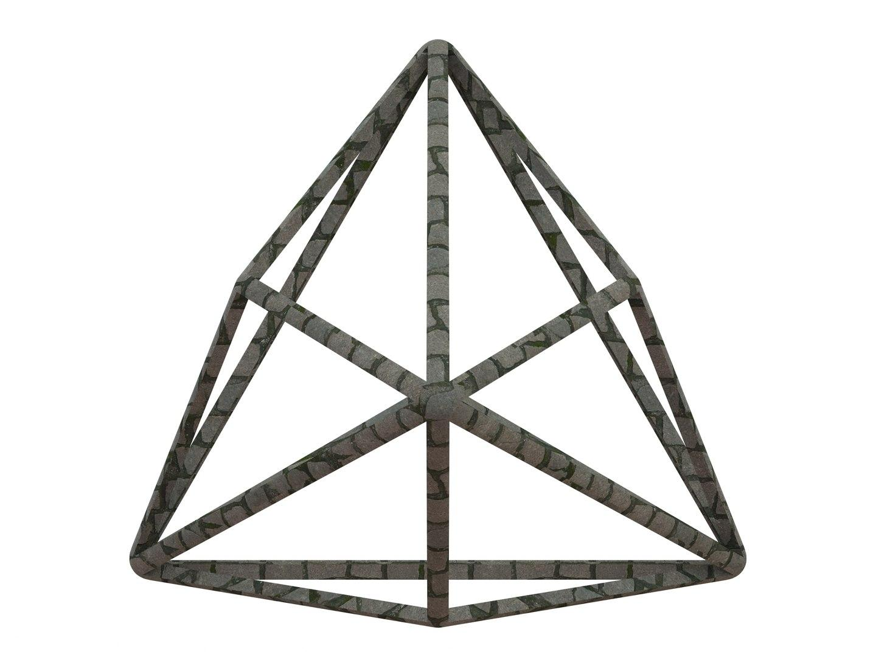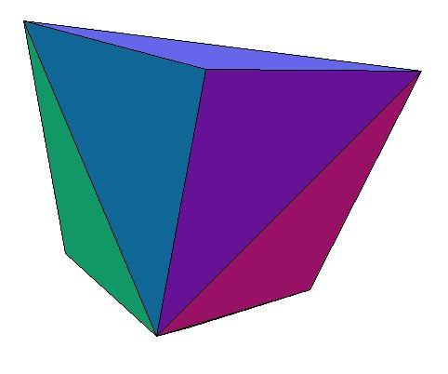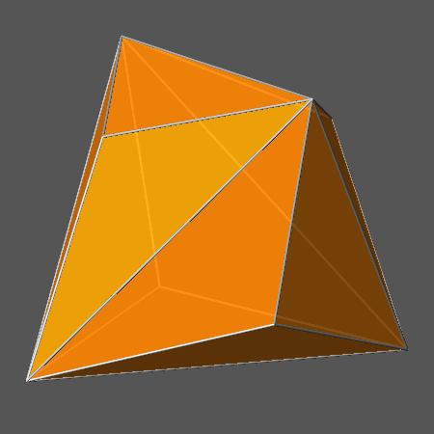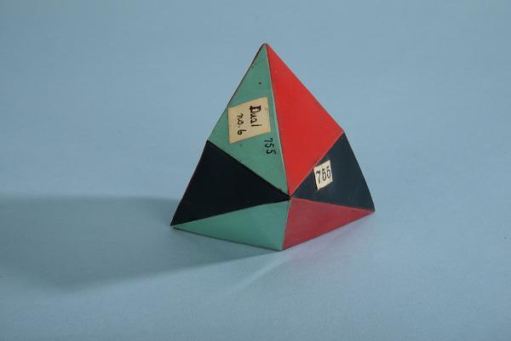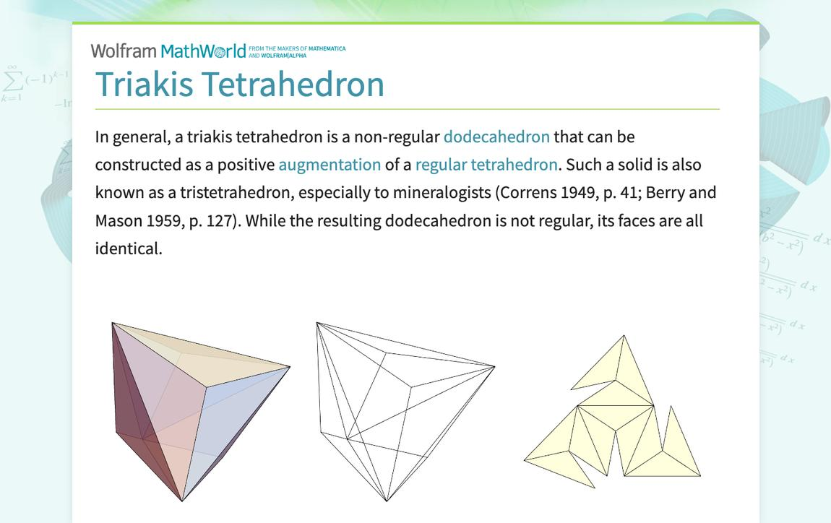

Geometric Structure
# Source: AI Source: Provided by: [Data Path: Persons Table -> ID Column: 1, Name_En Column: Motasem Essam] -> From: [ChatGPT] on [7/25/2026]
- It is based on a regular tetrahedron.
- A triangular pyramid is attached to each of the four original triangular faces.
- Each original tetrahedral face is divided into three smaller triangular faces.
- The resulting solid has 12 congruent isosceles triangles.
- The solid is convex and has tetrahedral symmetry.

Face Structure
# Source: AI Source: Provided by: [Data Path: Persons Table -> ID Column: 1, Name_En Column: Motasem Essam] -> From: [ChatGPT] on [7/25/2026]
The Triakis Tetrahedron has:
- 12 faces in total.
- All faces are congruent isosceles triangles.
- Each triangular face has two equal shorter edges and one longer edge.
- The shorter-to-longer edge ratio is $3:5$.

Edge Structure
# Source: AI Source: Provided by: [Data Path: Persons Table -> ID Column: 1, Name_En Column: Motasem Essam] -> From: [ChatGPT] on [7/25/2026]
The solid has 18 edges, divided into two groups:
- 12 shorter edges.
- 6 longer edges.
The shorter edges form the triangular pyramid faces, while the longer edges correspond to the edges of the original tetrahedral framework.

Vertex Structure
# Source: AI Source: Provided by: [Data Path: Persons Table -> ID Column: 1, Name_En Column: Motasem Essam] -> From: [ChatGPT] on [7/25/2026]
The Triakis Tetrahedron has 8 vertices, divided into two groups:
- 4 vertices of degree 3: Three triangular faces meet at each of these pointed vertices.
- 4 vertices of degree 6: Six triangular faces meet at each of these vertices.
The four degree-3 vertices are the apices of the attached pyramids, while the four degree-6 vertices correspond to the vertices of the original tetrahedron.
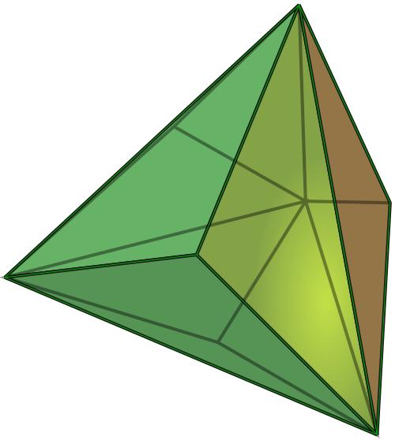

Mathematical Properties
# Source: AI Source: Provided by: [Data Path: Persons Table -> ID Column: 1, Name_En Column: Motasem Essam] -> From: [ChatGPT] on [7/25/2026]
12
Faces
18
Edges
8
Vertices
129.52°
Dihedral angle (approximately)
Euler's formula
$$V-E+F=2$$
$$8-18+12=2$$
The solid satisfies Euler's polyhedron formula.

Edge-length ratio
# Source: AI Source: Provided by: [Data Path: Persons Table -> ID Column: 1, Name_En Column: Motasem Essam] -> From: [ChatGPT] on [7/25/2026]
Let $s$ be the shorter edge and $L$ the longer edge.
$$\frac{s}{L}=\frac{3}{5}$$
Therefore:
$$L=\frac{5}{3}s$$
This ratio applies to the standard Catalan Triakis Tetrahedron.

Symmetry
# Source: AI Source: Provided by: [Data Path: Persons Table -> ID Column: 1, Name_En Column: Motasem Essam] -> From: [ChatGPT] on [7/25/2026]
The Triakis Tetrahedron has tetrahedral symmetry, represented by the symmetry group $T_{d}$.
Its symmetry includes:
- Three-fold rotational axes.
- Two-fold rotational axes.
- Reflection planes.
- A tetrahedral arrangement of its vertices.
It is face-transitive, meaning that every face can be mapped onto any other face by a symmetry of the solid. However, it is not vertex-transitive because its vertices have two different configurations.

Surface Area and Volume
# Source: AI Source: Provided by: [Data Path: Persons Table -> ID Column: 1, Name_En Column: Motasem Essam] -> From: [ChatGPT] on [7/25/2026]
Let $s$ represent the length of a shorter edge.
For the standard Triakis Tetrahedron:
Surface area
$$SA=\frac{5\sqrt{11}}{3}s^{2}$$
Volume
$$V=\frac{25\sqrt{2}}{36}s^{3}$$
These formulas use the shorter-edge normalization.

Relationship to Other Solids

Dual: Truncated Tetrahedron
# Source: AI Source: Provided by: [Data Path: Persons Table -> ID Column: 1, Name_En Column: Motasem Essam] -> From: [ChatGPT] on [7/25/2026]
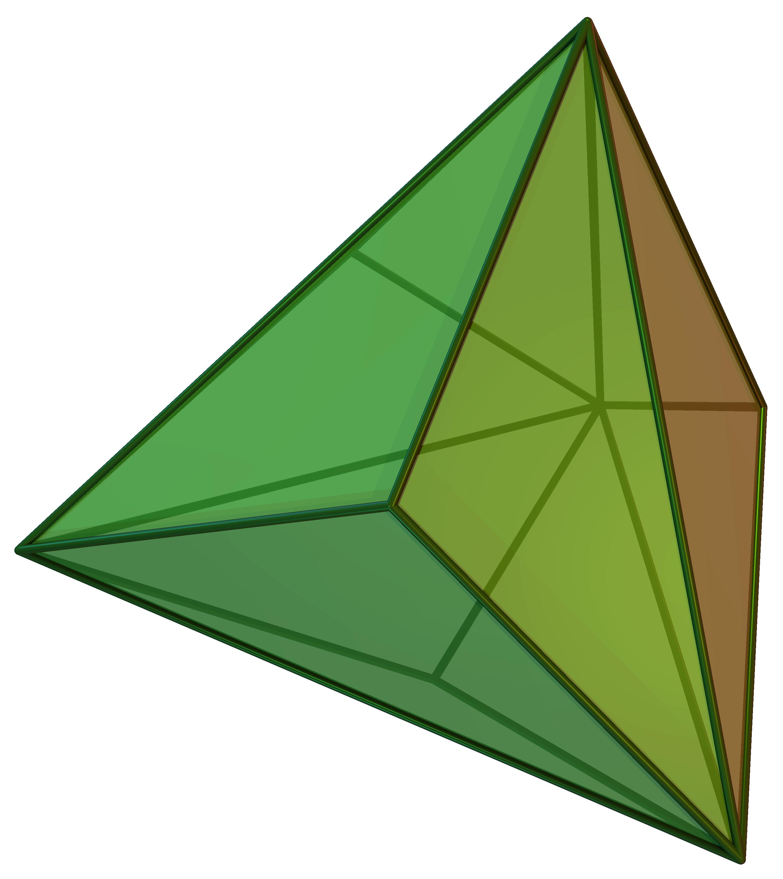
Triakis Tetrahedron
Catalan solid
<icon name="arrow-left-right" size="xl"/>
Duality
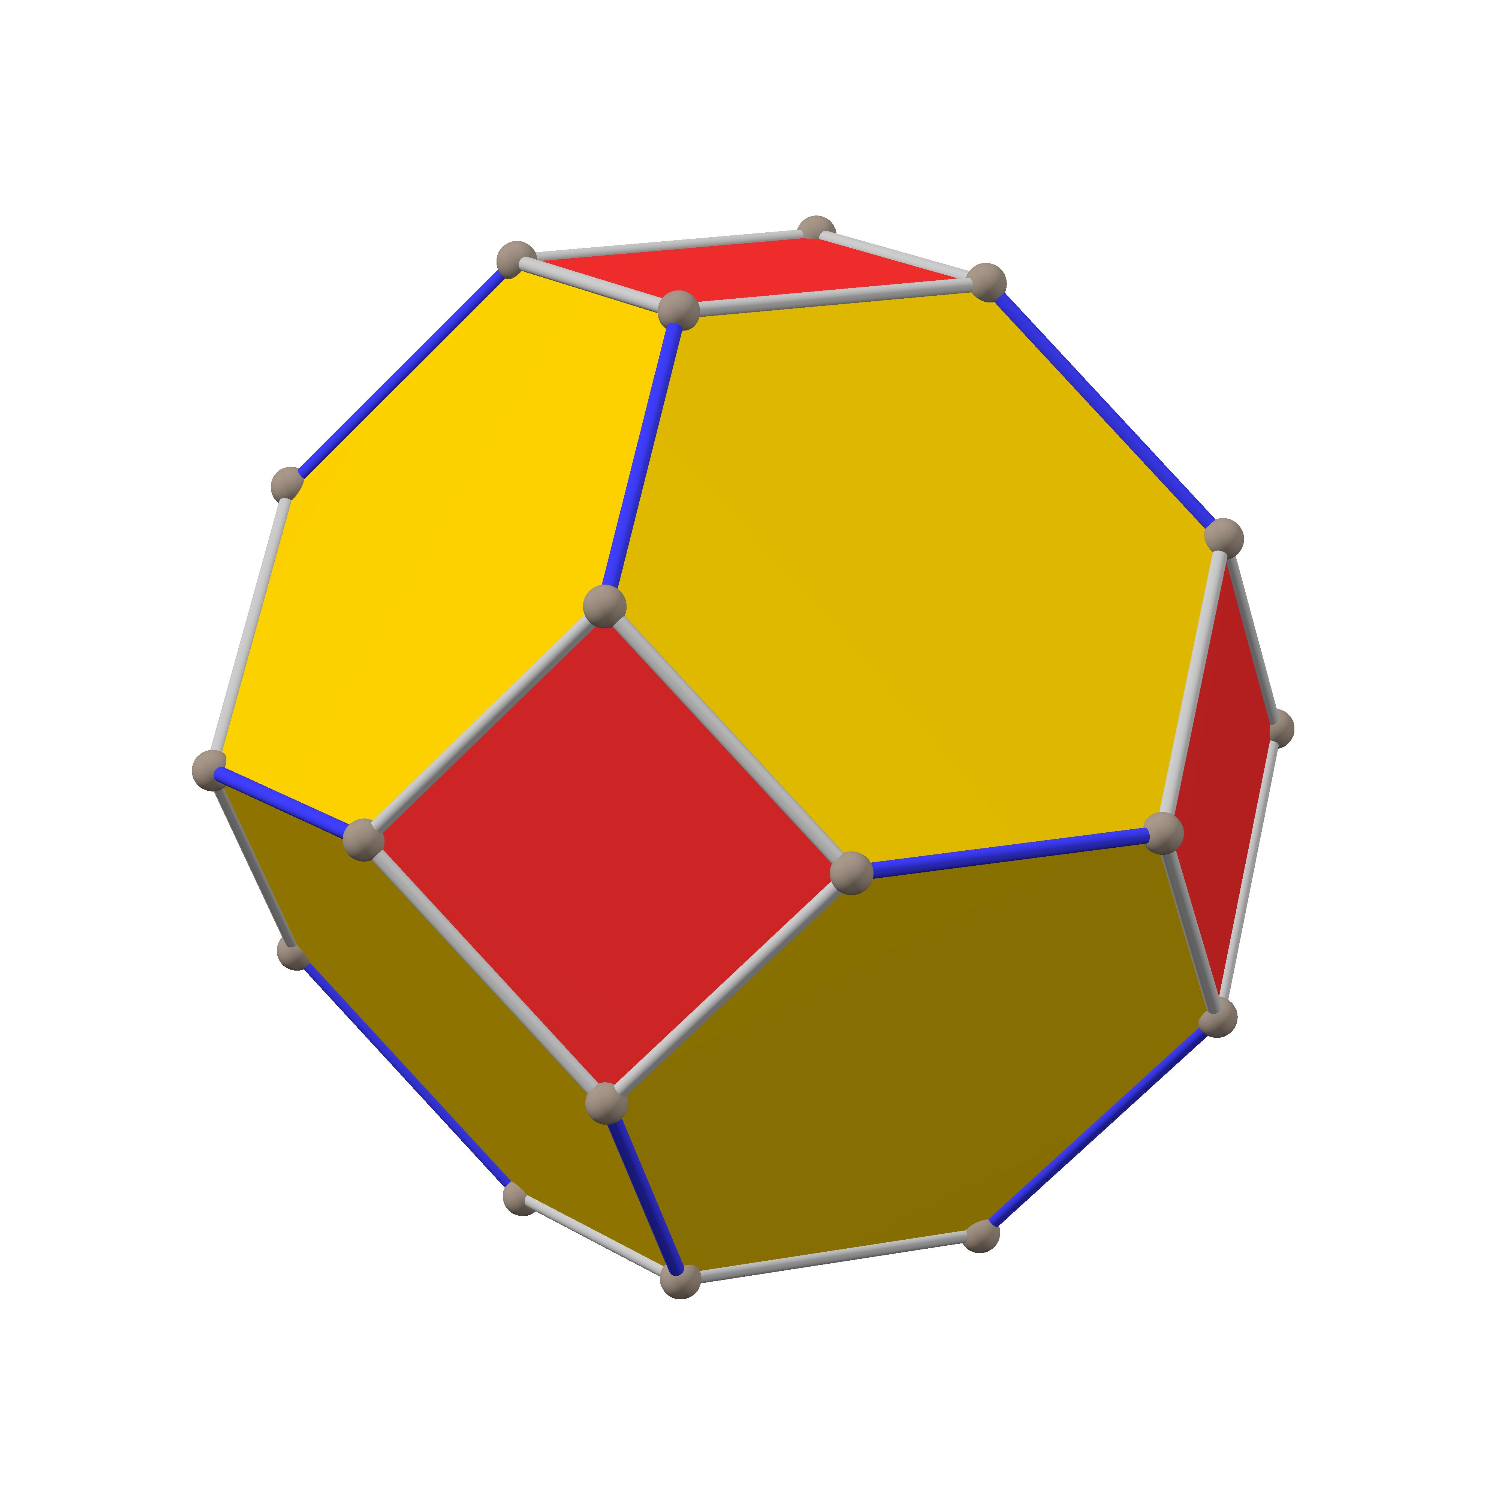
Truncated Tetrahedron
Archimedean solid
The Triakis Tetrahedron is the dual of the Truncated Tetrahedron.
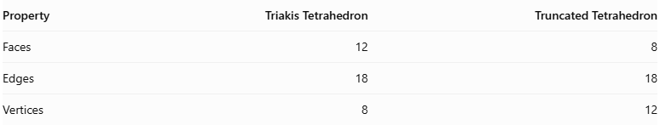
Property | Triakis Tetrahedron | Truncated Tetrahedron
Faces | 12 | 8
Edges | 18 | 18
Vertices | 8 | 12
In duality, the faces of one solid correspond to the vertices of the other, and their edges correspond to each other.

Construction of Triakis Tetrahedron

Geometric Instruments Used
# Source: AI Source: Provided by: [Data Path: Persons Table -> ID Column: 1, Name_En Column: Motasem Essam] -> From: [ChatGPT] on [7/25/2026]
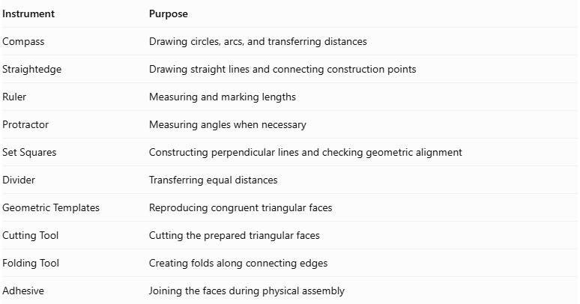
Instrument | Purpose
Compass | Drawing circles, arcs, and transferring distances
Straightedge | Drawing straight lines and connecting construction points
Ruler | Measuring and marking lengths
Protractor | Measuring angles when necessary
Set Squares | Constructing perpendicular lines and checking geometric alignment
Divider | Transferring equal distances
Geometric Templates | Reproducing congruent triangular faces
Cutting Tool | Cutting the prepared triangular faces
Folding Tool | Creating folds along connecting edges
Adhesive | Joining the faces during physical assembly

Instrument-Based Construction Procedures

Step 1: Construct the Regular Tetrahedron
# Source: AI Source: Provided by: [Data Path: Persons Table -> ID Column: 1, Name_En Column: Motasem Essam] -> From: [ChatGPT] on [7/25/2026]
- Draw an equilateral triangle with side length $a$.
- Construct its center by drawing its medians.
- Construct a perpendicular to the triangle's plane through its center.
- Determine the fourth vertex using the regular tetrahedron's required height.
- Connect the fourth vertex to the three vertices of the triangular base.
- Verify that all six edges have equal lengths.
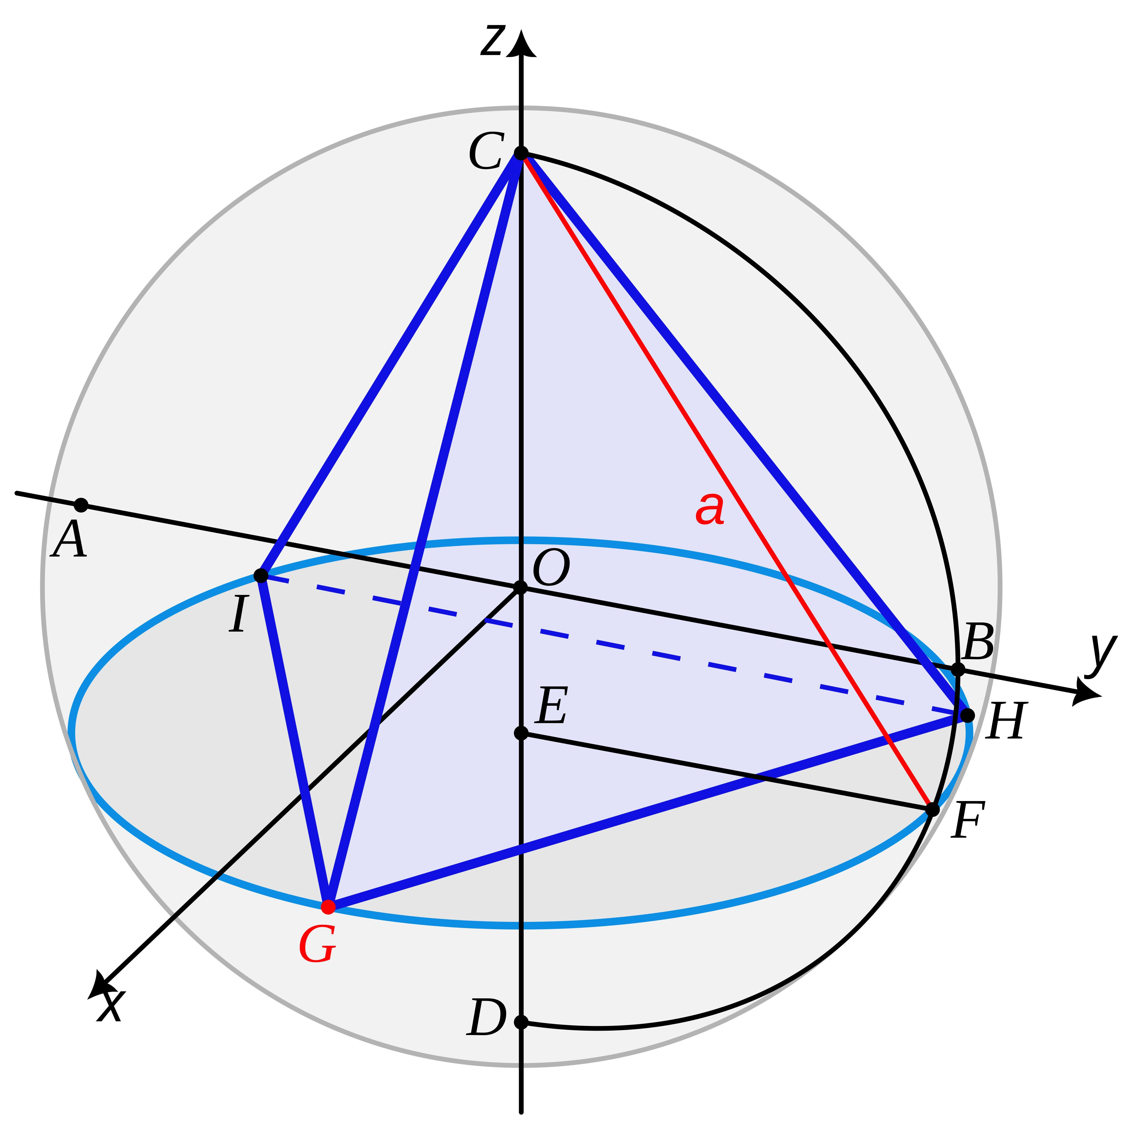

Step 2: Locate the Centers of the Four Faces
# Source: AI Source: Provided by: [Data Path: Persons Table -> ID Column: 1, Name_En Column: Motasem Essam] -> From: [ChatGPT] on [7/25/2026]
- Identify the four equilateral triangular faces of the tetrahedron.
- Construct the center of each triangular face using its medians.
- Mark the four face centers.
- Verify that each center is equidistant from the three vertices of its corresponding face.
These centers determine the positions of the four triangular pyramid apexes.
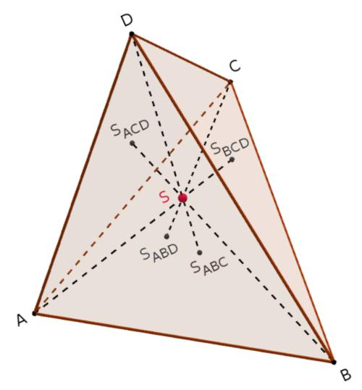

Step 3: Construct Perpendicular Lines Through the Face Centers
# Source: AI Source: Provided by: [Data Path: Persons Table -> ID Column: 1, Name_En Column: Motasem Essam] -> From: [ChatGPT] on [7/25/2026]
- Select one triangular face.
- Locate its center.
- Construct a line perpendicular to the plane of that face through its center.
- Extend the line outward from the tetrahedron.
- Repeat for the other three faces.
Each perpendicular line defines the direction in which an attached pyramid apex will be positioned.

Step 4: Determine the Pyramid Heights
# Source: AI Source: Provided by: [Data Path: Persons Table -> ID Column: 1, Name_En Column: Motasem Essam] -> From: [ChatGPT] on [7/25/2026]
For a central regular tetrahedron with edge length $a$, the required perpendicular height of each attached triangular pyramid is:
$$h=\frac{\sqrt{6}}{15}a$$
- Set the ruler to the required height.
- Measure this distance along each outward perpendicular line.
- Mark the position of each pyramid apex.
- Repeat for all four faces.
This height produces the standard Triakis Tetrahedron with congruent isosceles triangular faces.

Step 5: Construct the Triangular Pyramid Faces
# Source: AI Source: Provided by: [Data Path: Persons Table -> ID Column: 1, Name_En Column: Motasem Essam] -> From: [ChatGPT] on [7/25/2026]
- Select one face of the central tetrahedron.
- Identify its three original vertices.
- Connect the newly marked apex to each of the three vertices.
- Form three isosceles triangular lateral faces.
- Repeat for all four original tetrahedron faces.
Each attached pyramid contributes three exterior triangular faces.

Step 6: Complete the Polyhedral Structure
# Source: AI Source: Provided by: [Data Path: Persons Table -> ID Column: 1, Name_En Column: Motasem Essam] -> From: [ChatGPT] on [7/25/2026]
- Combine the four attached pyramids with the central tetrahedron.
- Treat the original tetrahedron faces as internal joining surfaces.
- Retain only the 12 exterior triangular faces.
- Verify that all triangular faces are congruent.
- Check that the resulting solid is convex and has tetrahedral symmetry.
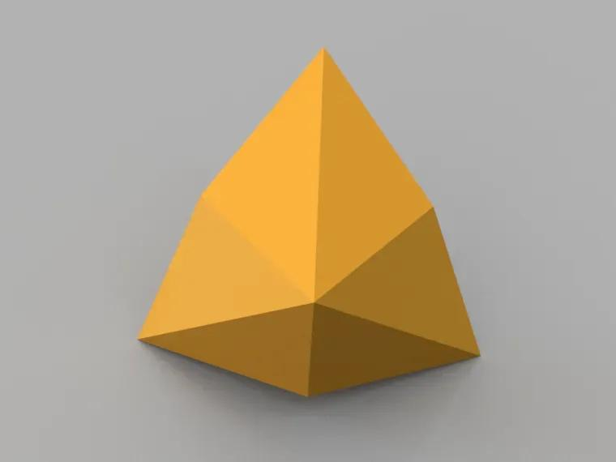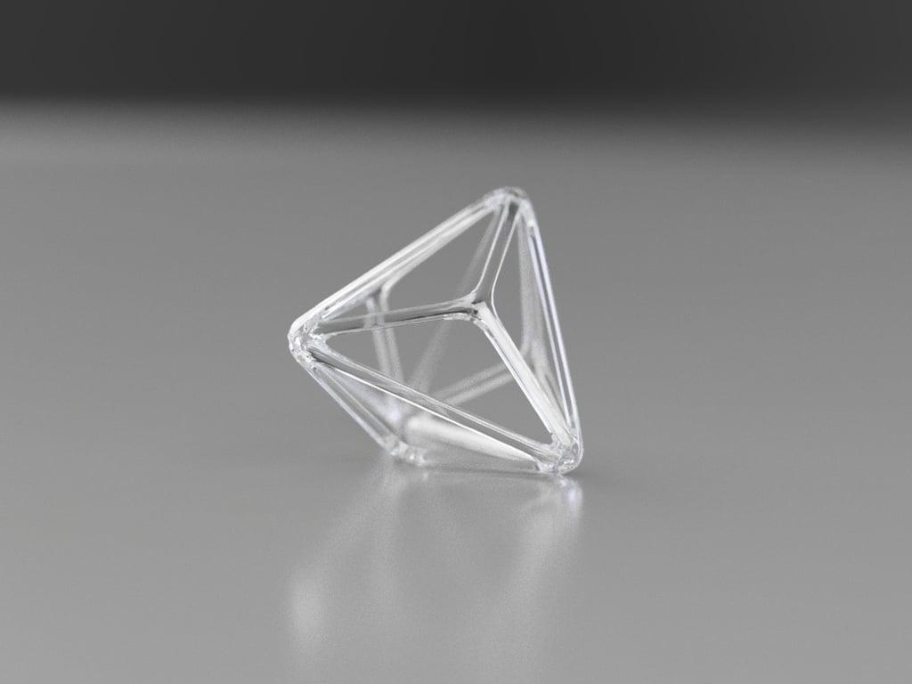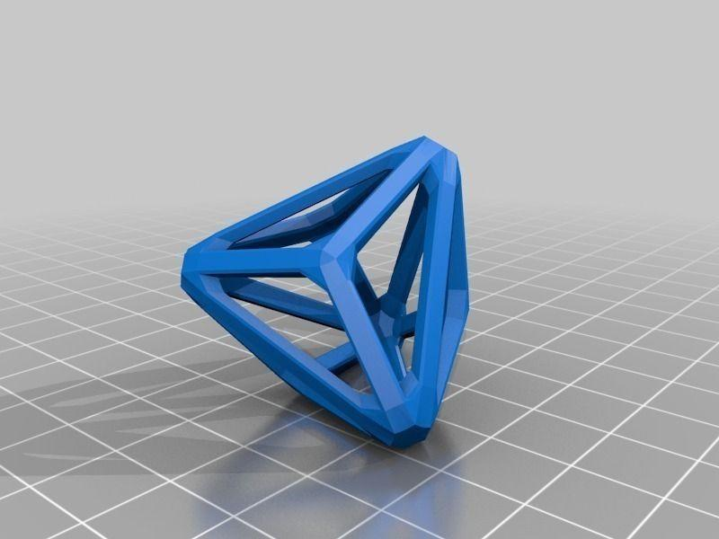

Step 7: Prepare the Faces for Physical Assembly
# Source: AI Source: Provided by: [Data Path: Persons Table -> ID Column: 1, Name_En Column: Motasem Essam] -> From: [ChatGPT] on [7/25/2026]
- Construct an accurate template for one isosceles triangular face.
- Reproduce the template 12 times.
- Mark the long and short edges.
- Arrange the triangles according to a verified polyhedral net.
- Cut out the faces and prepare their joining tabs if necessary.
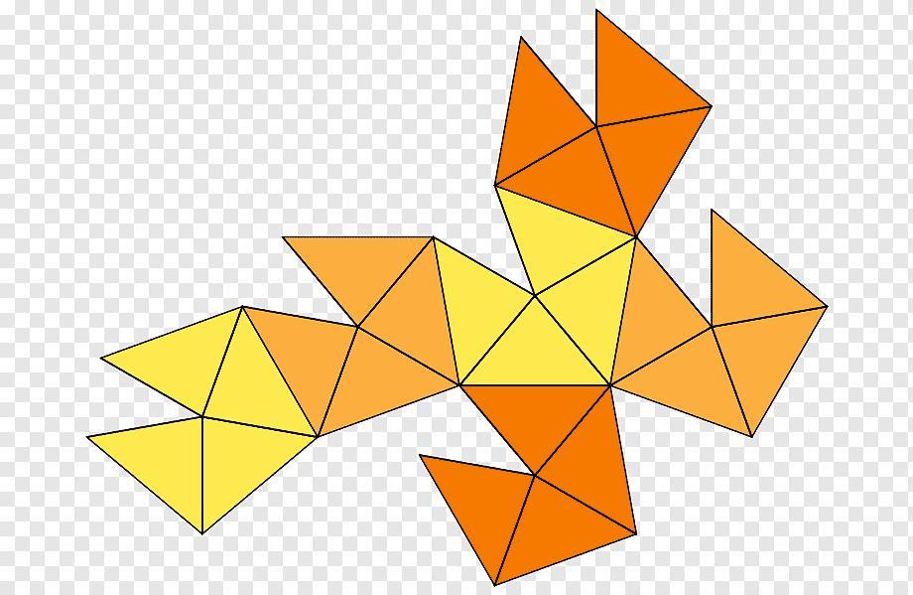

Step 8: Assemble the Three-Dimensional Solid
# Source: AI Source: Provided by: [Data Path: Persons Table -> ID Column: 1, Name_En Column: Motasem Essam] -> From: [ChatGPT] on [7/25/2026]
- Fold or position the triangular faces along their designated edges.
- Join the faces according to the verified net.
- Ensure that six edges meet at each of the four original tetrahedron vertices.
- Ensure that three edges meet at each of the four pyramid apexes.
- Close the remaining openings.
- Inspect the completed solid for symmetry and convexity.

Key Points
# Source: AI Source: Provided by: [Data Path: Persons Table -> ID Column: 1, Name_En Column: Motasem Essam] -> From: [ChatGPT] on [7/25/2026]
- The Triakis Tetrahedron is a Catalan solid.
- It has 12 congruent isosceles triangular faces.
- It has 18 edges and 8 vertices.
- Its edges consist of 12 shorter edges and 6 longer edges.
- Its vertices have two configurations: degree 3 and degree 6.
- It is the dual of the Truncated Tetrahedron.
- It has tetrahedral symmetry $T_{d}$.
- It is convex and face-transitive.

Conclusion
# Source: AI Source: Provided by: [Data Path: Persons Table -> ID Column: 1, Name_En Column: Motasem Essam] -> From: [ChatGPT] on [7/25/2026]
The Triakis Tetrahedron is an important member of the Catalan solids family. Its structure is based on a regular tetrahedron with four triangular pyramids attached to its faces. Its 12 congruent triangular faces, two types of vertices, and dual relationship with the Truncated Tetrahedron make it an interesting example of polyhedral construction and duality.

